SUPPLEMENTAL DATA

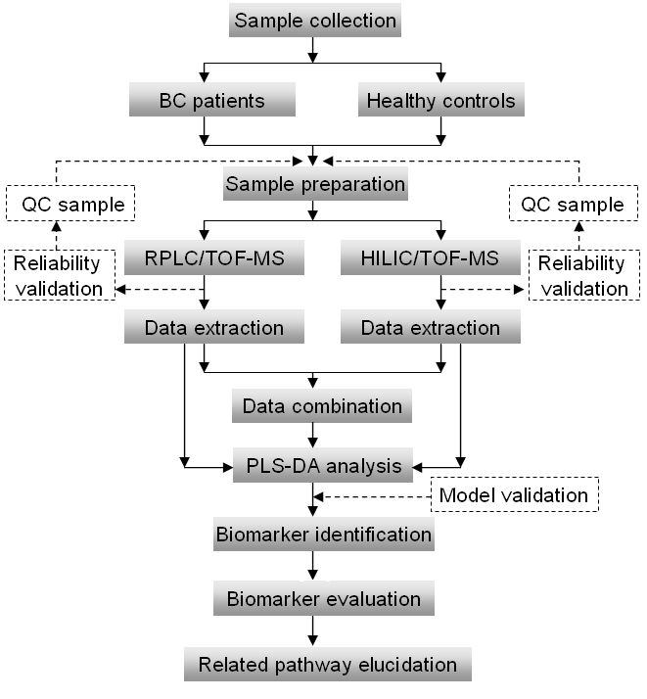
FIG. S1. Workflow of urinary metabonomic study of BC based on both RPLC and HILIC coupled to MS analysis.

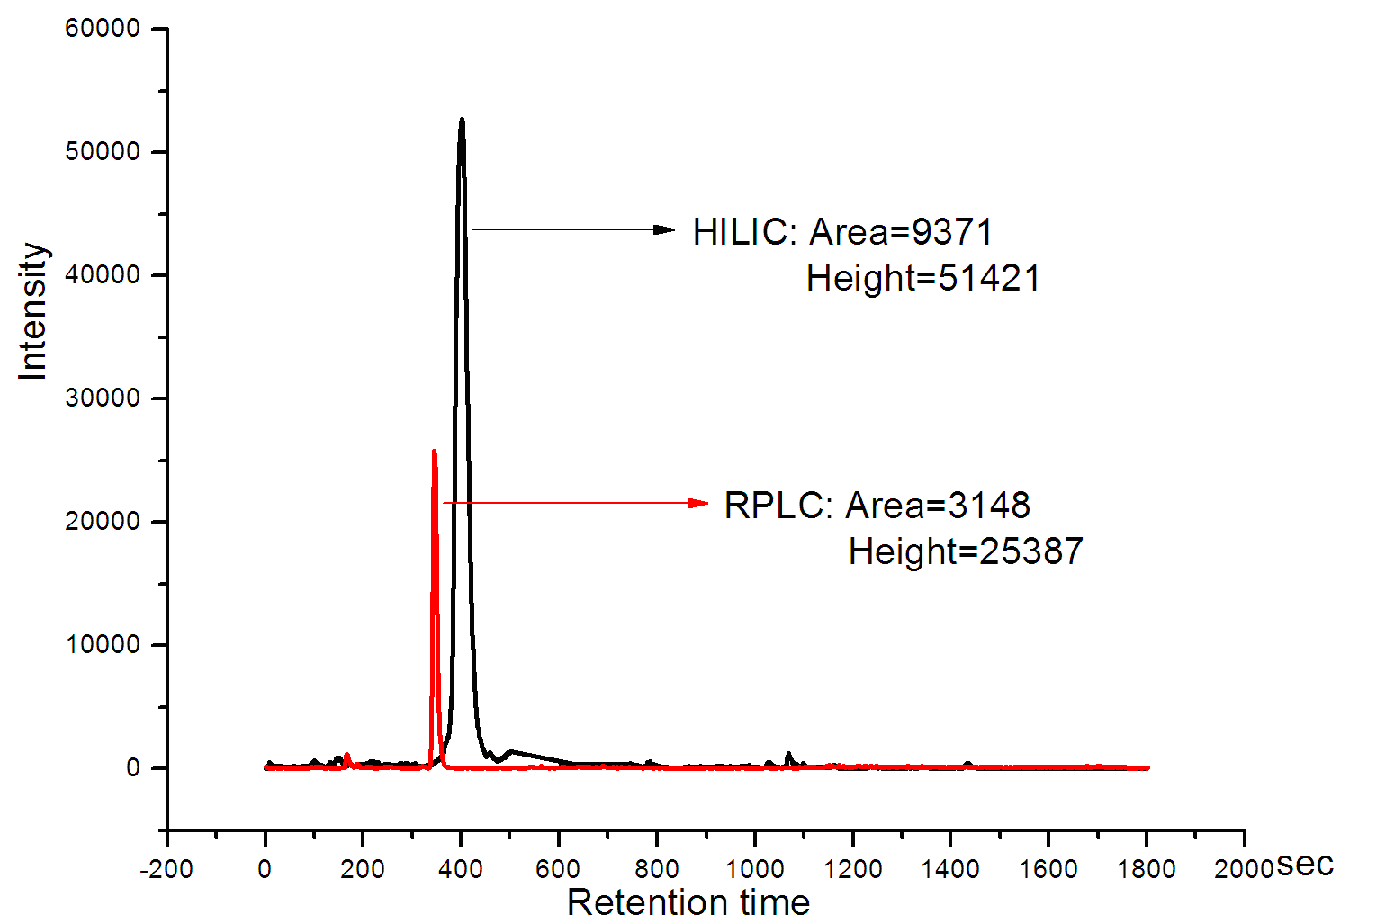
FIG. S2. Ion m/z 180.07 from LC-MS. The intensity in HILIC separation is approximately twice the area of that in the RPLC mode.

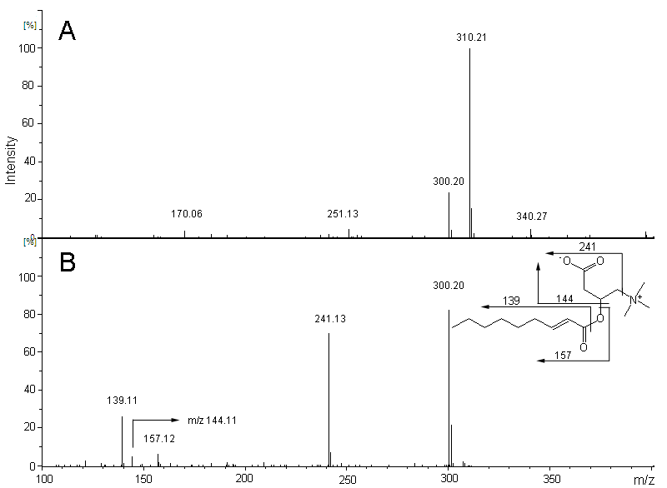
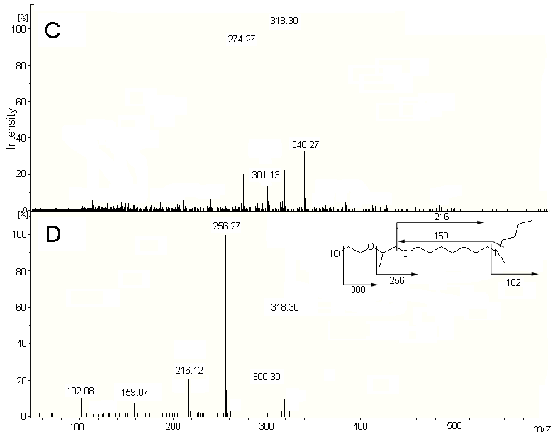
FIG. S3. Identification of selected potential biomarkers. (A) Corresponding MS spectrum in EIC. (m/z 300.20, t_{R}= 11.4 min in RPLC). (B) MS/MS spectrum of the metabolite (m/z 300.20). The collision energy was set at 15 eV. (C) Corresponding MS spectrum in EIC. (m/z 318.30, t_{R}= 15.1 min in RPLC). (D) MS/MS spectrum of the metabolite (m/z 318.30). The collision energy was set at 20 eV.
The identification process of carnitine C9:1 describes as follows. C₁₆H₂₉NO₄ was calculated according to the exact mass, the nitrogen rule, and the isotope pattern. Product ion spectrum was generated by MS/MS experiments. Authentic standard is commercially unavailable, so we searched literature and metabolite databases to confirm the structure. Neutral loss of N(CH₃)₃ is specific for carnitine species. Intensity of ions m/z 139.11 is almost three times higher than that of ions m/z 157.12, which indicates the position of the double bond. The structure is rationally inferred based on the above information. The identification process of the metabolites with m/z 318.30 (component I) describes as follows. The corresponding peak from RPLC was found according to the retention time in the extracted ion chromatogram (EIC) of m/z 318.30. Ions of m/z 340.27 are [M+Na] ⁺ that usually coexist with [M+H] ⁺ in EIC. C₁₈H₃₉NO₃ was calculated according to the exact mass, the isotope pattern and nitrogen rule. To elucidate the structure of the potential biomarker, MS/MS experiments were performed with the spectrum shown in (D). MS and MS/MS data are consistent with the structure of BAHE (2-(1-(7-(butyl(ethyl)amino)heptyloxy)propan-2-yloxy)ethanol) with its structure indicated in the insert. What we need to emphasize is that the identity of component I as BAHE is tentative because BAHE standard is not available for the confirmation. Additional effort is required to confirm the identification.

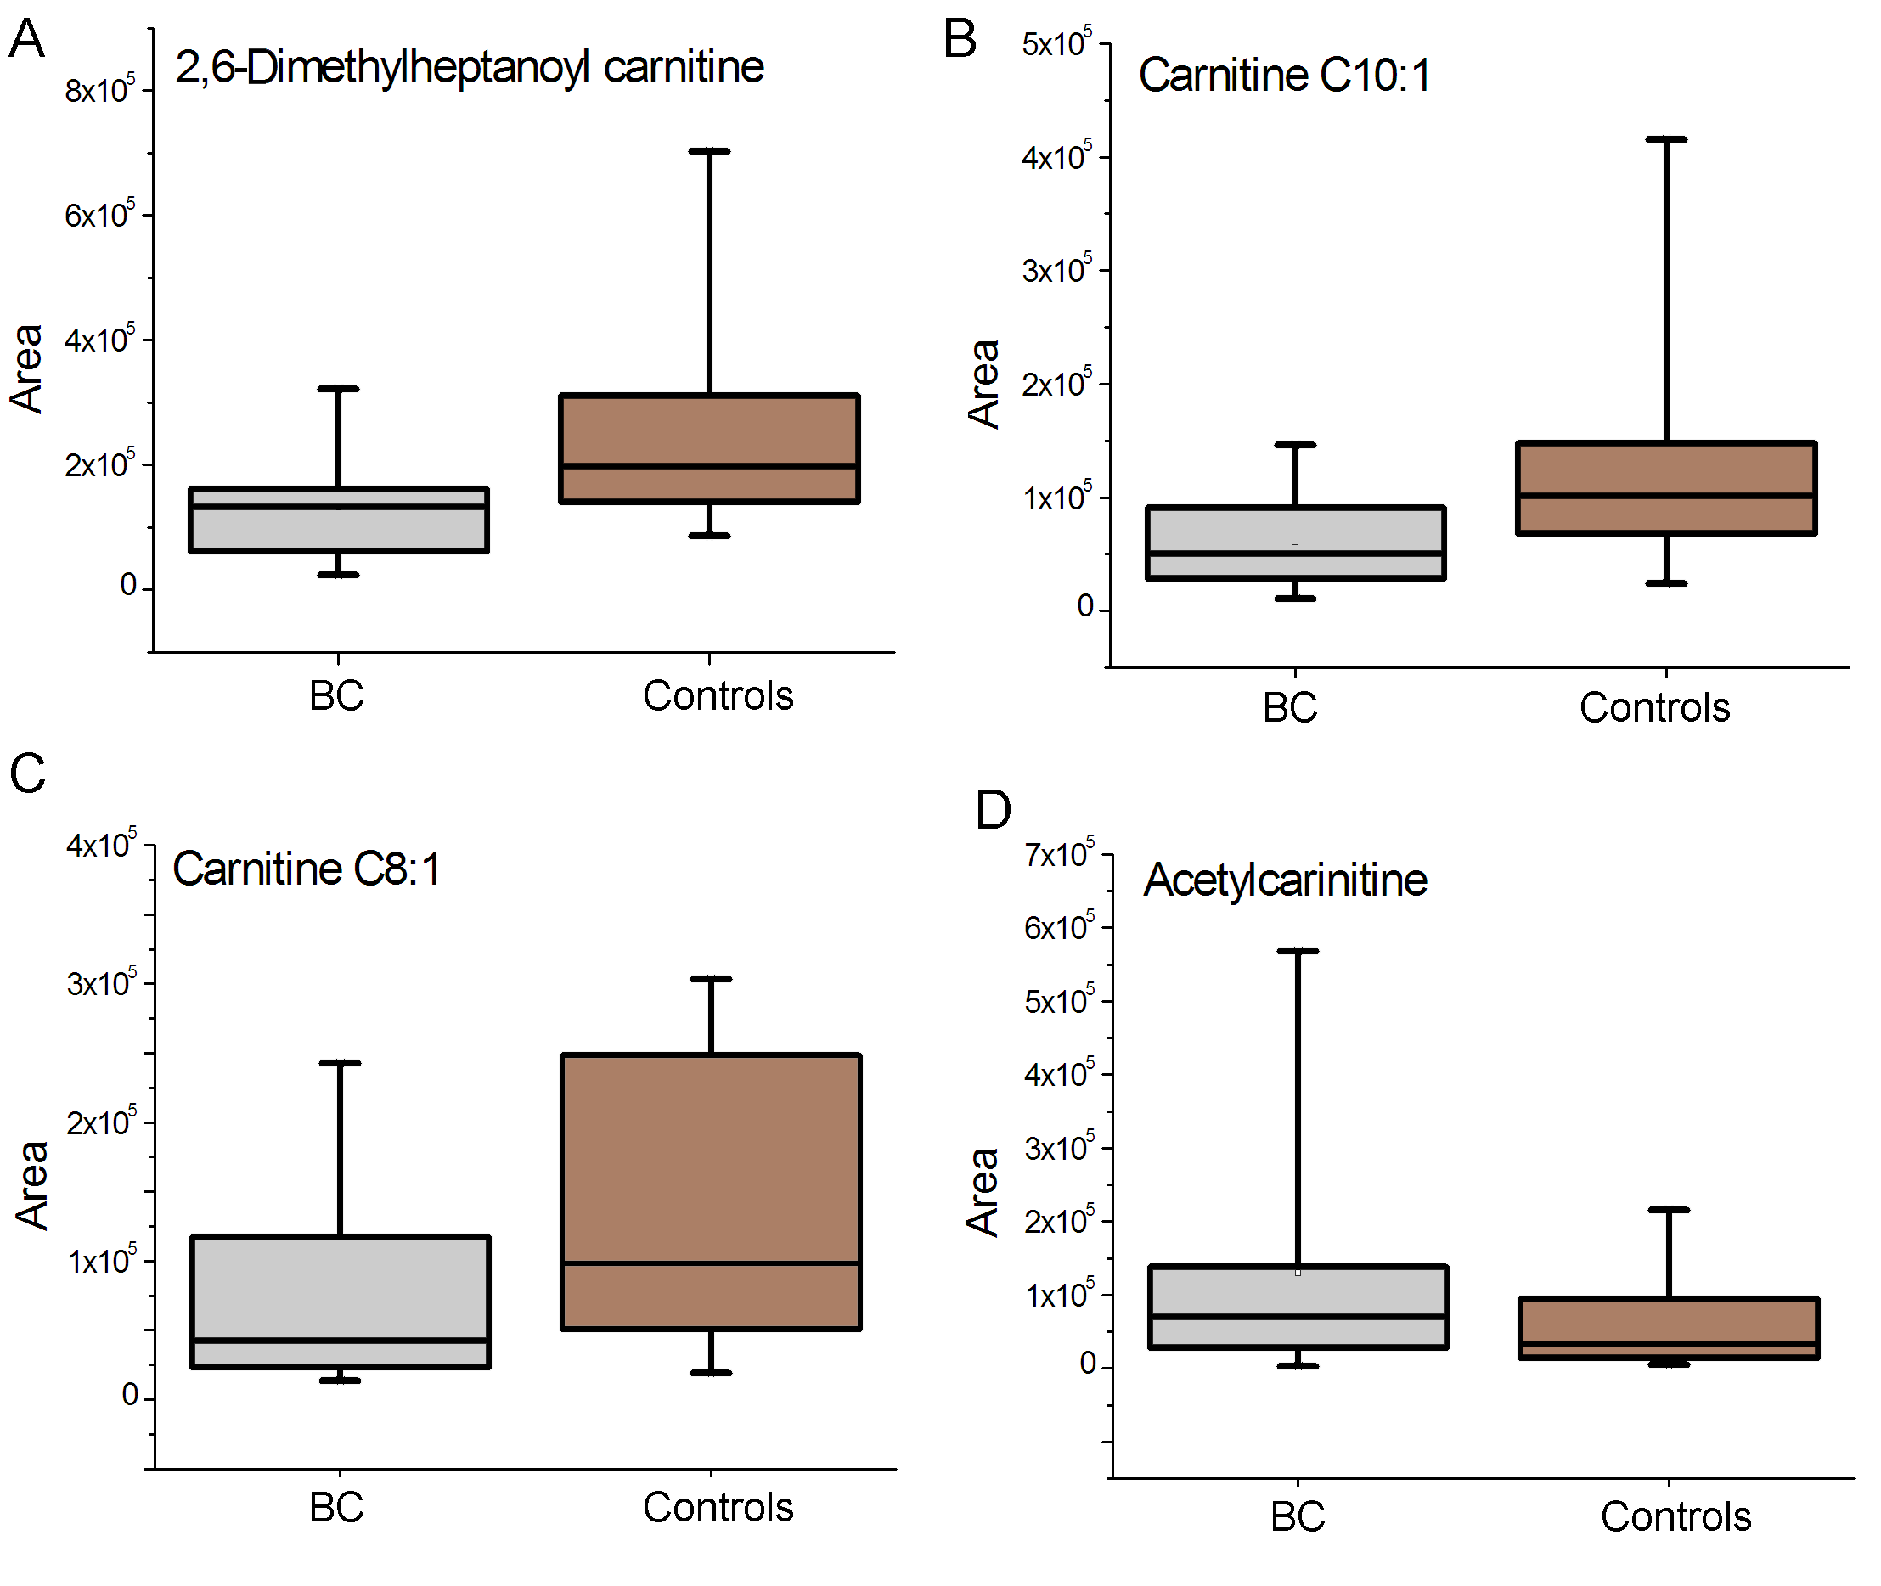
FIG. S4. Variation of urine (A) 2, 6-dimethylheptanoyl carnitine, (B) carnitine C10:1, (C) carnitine C8:1, and (D) acetylcarnitine levels in BC patients compared to controls. The boxes are drawn from the 25th to 75th percentiles in the intensity distribution. The median, or 50th percentile, is drawn as a black horizontal line inside the box. Urinary acylcarnitine deficiency was prevalent in the BC. Increased concentrations of acetylcarnitine were observed.

